NEW NVR、IPC Forget password recovery tool

- NVR forgot password recovery.
This method applies to all new and old NVR2.0 and 1.0

- Open the NVR that needs to recover the password, and find the current display time of the NVR in the upper right corner of the main page (1.0 NVR in the lower right corner)
- Enable the SuperPassword.exe tool, in Gen Time, enter the time of the current NVR, click Do it, Password will generate a temporary password. Log in with the temporary password generated by admin user + on NVR, and then in the recovery interface of NVR, select "user" to restore the default, NVR password can be restored to the factory default.
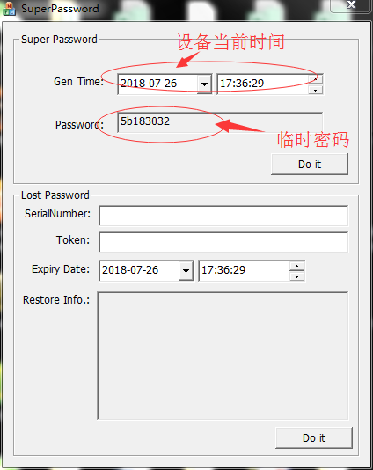
Note: each time the temporary password is calculated, it will be effective within 1 hours.
- IPC forgot password recovery.
This method applies to the landing interface with "forget the password?" Options for models
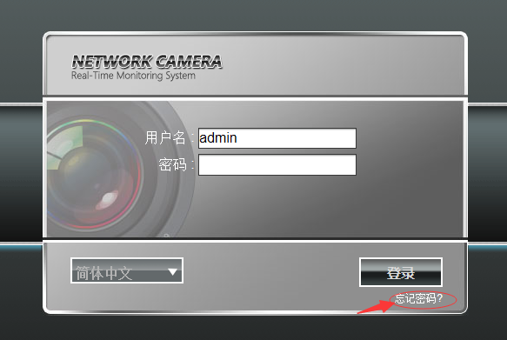
- 1. Connecting IPC to NVR, when the connection is successful, the upper right-hand corner of the IPC image displayed on the NVR channel screen will show the specific time of the current IPC. IPC with forgotten passwords can be added using private protocols (i8, i8s, i8H, SLINK, i9 and other private protocols). Private protocols can automatically add passwords without manual input verification.
- IE logs on to IPC, finds "Forget Password" in the login interface, clicks in, enters the user name admin, clicks next, appears the following picture
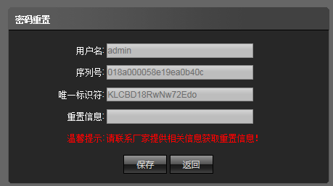

3. Enable the SuperPassword.exe tool and fill in the "serial number" (you can copy and paste) in the Serial Number column; fill in the "unique identifier" (you can copy and paste) in the Token column; and fill in the current IPC time in the Expiry Date column (note: the time to fill in here is longer than IPC time, it is recommended to add one hour by default).

Click Do it, copy all the generated information to IPC's "Reset Information" column, click save; prompt successful operation, IPC password can be restored to the factory 23456.23456。

